Path Planning for Multiple Autonomous Guided Vehicles for Use in Warehouses

Team Members: Abhiram Dapke, Akshay Bapat, Sanket Acharya

Introduction

Since several years, the use of online shopping has grown exponentially, thanks to companies such as Amazon. In 2013, according to Amazon’s statistics, customers ordered more than 36.8 million items globally on Cyber Monday alone, which equates to 426 items per second. Managing such large numbers of deliveries requires a lot of planning and efficiency of work.

In order to assist the supply of such large numbers of products, Amazon Robotics employs the fleet of machines developed by Kiva Systems in 10 of its warehouses in the United States in California, Texas, New Jersey, Washington and Florida. This fleet consists of more than 15,000 Autonomous Guided Vehicles (AGVs) that work in warehouses to pick up shelves of products from the warehouse floor and bring them to a human employee who picks items and then packs them for shipping.

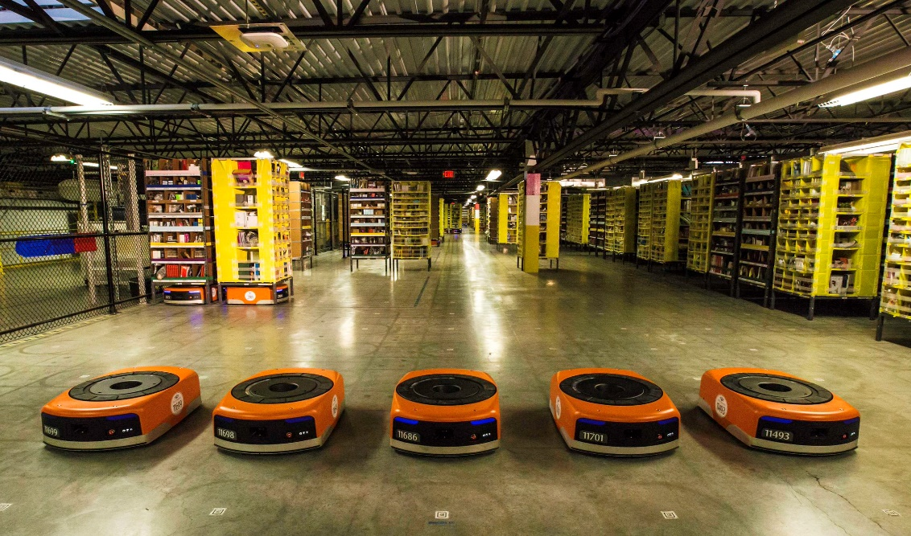

Figure : Kiva Systems Robots in a Warehouse

This project aims at simulating a downsized version of such a warehouse, in which a fixed number of AGVs operate in a grid of fixed size to pick up items from shelves and deliver them to the employees for packing. A schematic of the workspace and the system of bots is shown in the figure below. The vertical areas at the left and right ends of the workspace are drop off points for empty and filled shelves respectively. The grids represent areas where filled shelves will be stored. ‘S’ represents a possible start node, where bots will go to pick the items up. ‘R’ represents the bot that roams around the workspace and ‘G’ represents the goal node, where the bot is supposed to drop the item off. This schematic shows the workspace for a single pick up, drop off and a single robot, but the project will consider multiple entities.

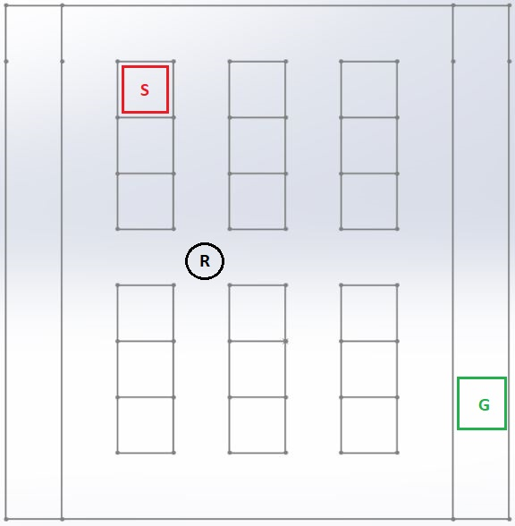

Figure : Proposed Workspace

Assumptions

1. Speed of the AGVs is constant.
2. No human interference is assumed in the workspace.
3. Assuming an 8\*8 grid where last column is the delivery grid and all the points the navigation space can be pick-up points.
4. 8 robots are used.
5. The robots can move only along fixed lines on the workspace floor.
6. Pick up location will be on the left and delivery location will be on the right.

Goal

Our final goal is to find a heuristic path for AGVs from the pick up location to the delivery location and formulate a model for their path planning and simulate this model in a real-time environment, i.e. warehouses. This involves collision and bottleneck avoidance.

Software

The software we are going to use are Python and C++, depending on the nature of the application.

Method

The robots have designated pick up and drop off locations that are assigned to each robot according to the demand. The job is to pick up filled shelves from the pick up spot, drop them at the drop-off spot, after which the shelves are emptied. The emptied shelves are then picked up again and dropped off back at the original pick-up spot for refilling. Each robot calculates the shortest path from its source to its destination and starts moving the item along that path. If two or more robots have intersecting paths, they may collide, which is an unwanted scenario. If a robot finds that one or more other robots have arrived in its vicinity, the robot with lower priority stops or changes its path to avoid collision. The robots carrying filled shelves are defined to have higher priority.

References

1. J van den Berg, J Snoeyink, M Lin, D Manocha, “Centralized Path Planning for Multiple Robots: Optimal Decoupling into Sequential Plans”, Robotics: Science and Systems, 2009
2. P Svetska, MH Overmars, “Coordinated path planning for multiple robots”, Robotics and Autonomous Systems, Vol. 23, 125-152, 1998
3. M Saha, P Isto, “Multi-Robot Motion Planning by Incremental Coordination”
4. R D’Andrea, “A Revolution in the Warehouse: A Retrospective on Kiva Systems and the Grand Challenges Ahead”, IEEE Transactions on Automation Science and Engineering, Vol. 9, No. 4, October 2012
5. W Honig, S Kiesel, A Tinka, JW Durham, N Ayanian, “Persistent and Robust Execution of MAPF Schedules in Warehouses”, IEEE Robotics and Automation Letters, Vol. 4, No. 2, 2019
6. RKA Sakir, A Rusdinar, S Yuwono, AS Wibowo, Silvirianti, NT Jayanti, “Movement Control Algorithm of Weighted Automated Guided Vehicle Using Fuzzy Inference System”, International Conference on Control and Robotics Engineering, 2017
7. D Milner, “Swarm Robotics Algorithms: A Survey”, May 2007